2024 CALENDAR OF EVENTS – MALTA

January 2024

Valletta Baroque Festival
Dates: 18-28 January
Website: https://www.festivals.mt/vbf
Price: Different prices for different events, check the website for more information.

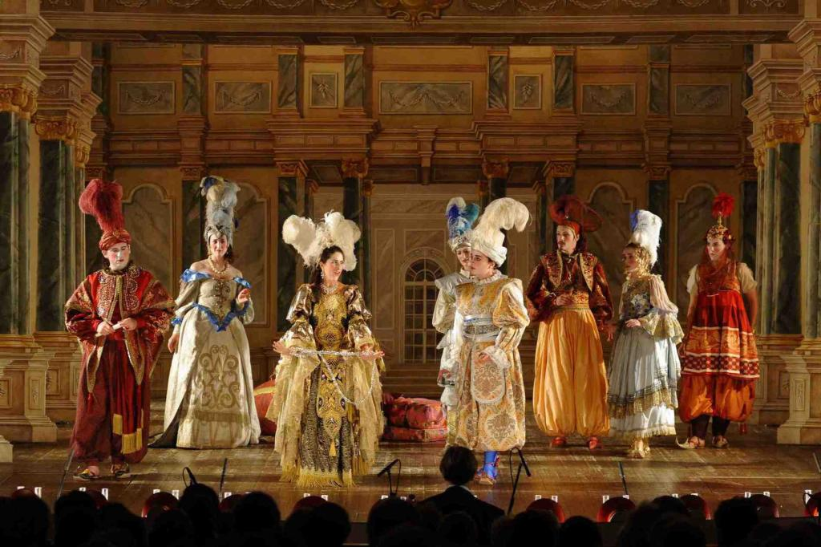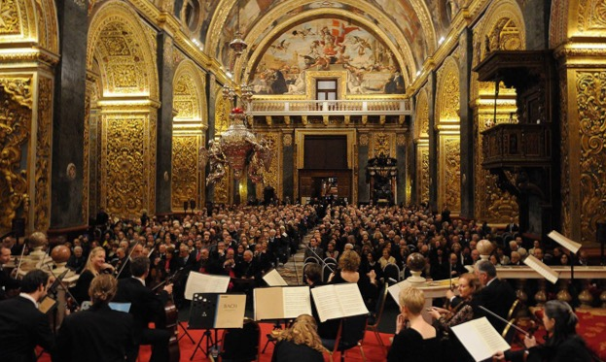

Since its launch in 2013, the Valletta Baroque Festival has treated audiences to a unique event featuring some of the best soloists and ensembles in the baroque music scene. Spanning over three weeks, the festival offers a quintessential experience of all that is Baroque as it takes place in exquisite venues such as St John’s Co-Cathedral, The Verdala Palace, Palazzo Parisio, and Teatru Manoel to name a few. These venues are authentic Baroque spaces adorned with lavish decor, sculptures and paintings that are typical of this period. Organised by Festivals Malta every January, under the artistic direction of Kenneth Zammit Tabona, the festival highlights the enormous versatility of the baroque idiom and its mass appeal. Above all the festival’s strength lies in the wonderful baroque settings that one finds in Valletta and the Maltese archipelago; a precious legacy that each and every one of us Maltese treasure.

February 2024

Carnival
Dates: 9-13 February
Website: Festivals Malta | Il-Karnival ta' Malta
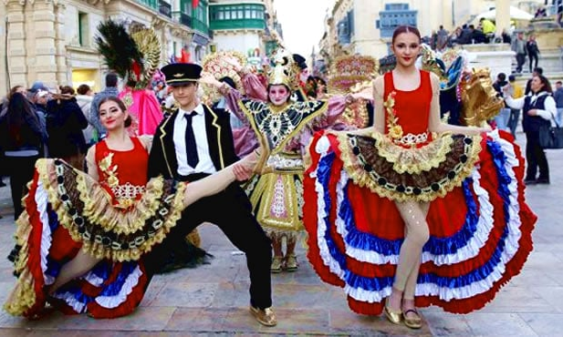
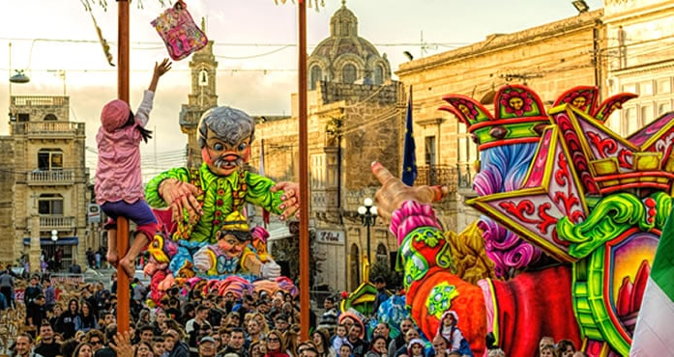
Price: Free

Spring is the time for carnivals, and if you're looking for a great party, this weekend of celebration won't disappoint. The center of the festivities is Valletta, but there are similar celebrations in small towns. Across the island, you'll find people in colorful costumes eagerly awaiting the grand parade. The party continues into the late hours in Paceville! Don't miss this colorful side of Malta!
April 2024

Malta Fireworks Festival
Dates: TBA
Website: https://www.maltafireworksfestival.com/
Price: Free
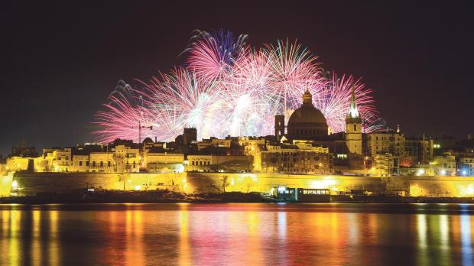
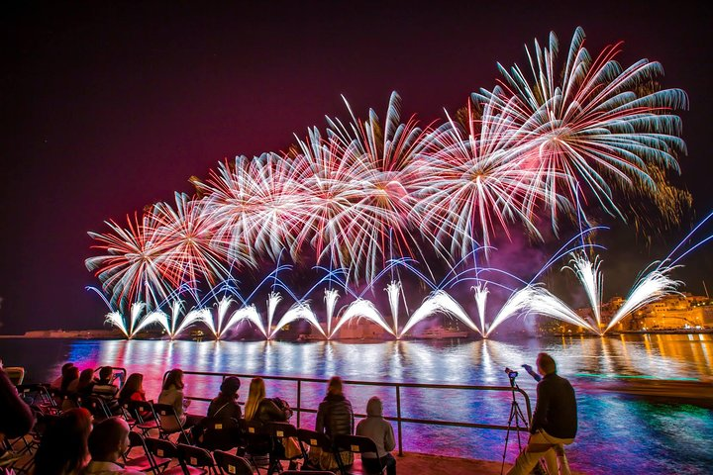

Each night of this festival promises to be a beautiful display of colour and coordination, and the closing night is bound to be a true spectacle.
The festival also has a competitive edge! Each year, the festival hosts a Pyro-musical competition, which means that the fireworks are designed to match the rhythm of a musical number! Awards are then distributed to the most impressive displays.

June 2024

Malta International Art Festival
Dates: 14-23 June
Website: Festivals Malta | Malta International Arts Festival
Price: Different prices for different events, check the website for more information.
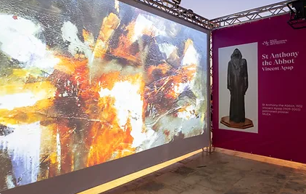
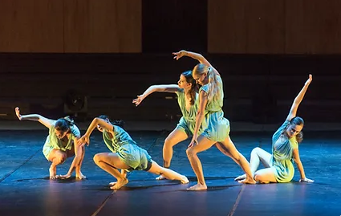

The Malta International Arts Festival (MIAF) blends innovation with accessibility - curating a programme of artistic excellence with strong contemporary aesthetics, accessible to a wide audience. MIAF goes beyond the conventional performance by hosting most of the programme within unique heritage sites. Every festival can programme a concert recital ... but this year MIAF is proposing concerts inside the subterranean 17th century cistern built by the Knights ... and invites audiences on a beautiful two-masted vessel to experience a theatre production set within the unique panoramic views of Grand Harbour.
MIAF isn’t just a festival ... it is an “experience” where Malta becomes the stage and the backdrop.

July 2024

Malta Jazz Festival
Dates: 8-13 July
Website: https://www.festivals.mt/mjf
Price: €15-€60
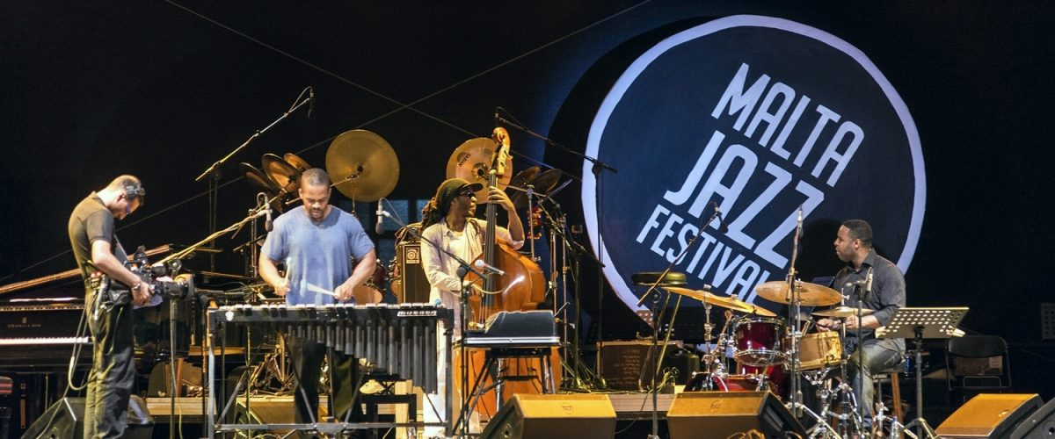
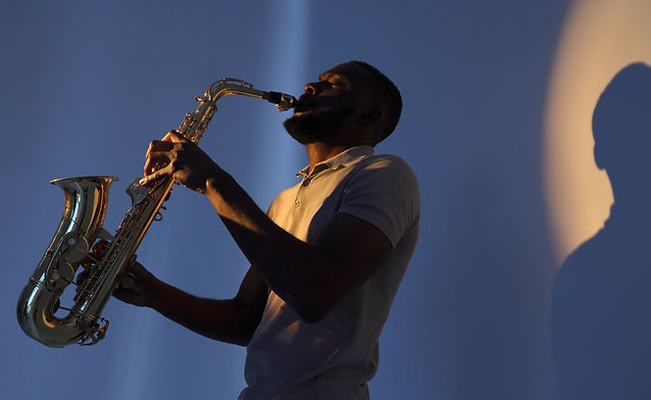

‘The Malta Jazz Festival is one of the longest-running festivals on the island and is considered by many as a beacon of artistic excellence. This year's edition is dedicated to two jazz icons that have recently left us: Ahmad Jamal and Wayne Shorter. During the festival, jazz enthusiasts, newcomers and some of the jazz world's foremost musicians rub shoulders in an intimate setting in the heart of the Mediterranean.’

Farsons Beer Festival
Dates: TBA
Website: https://farsonsbeerfestival.com/
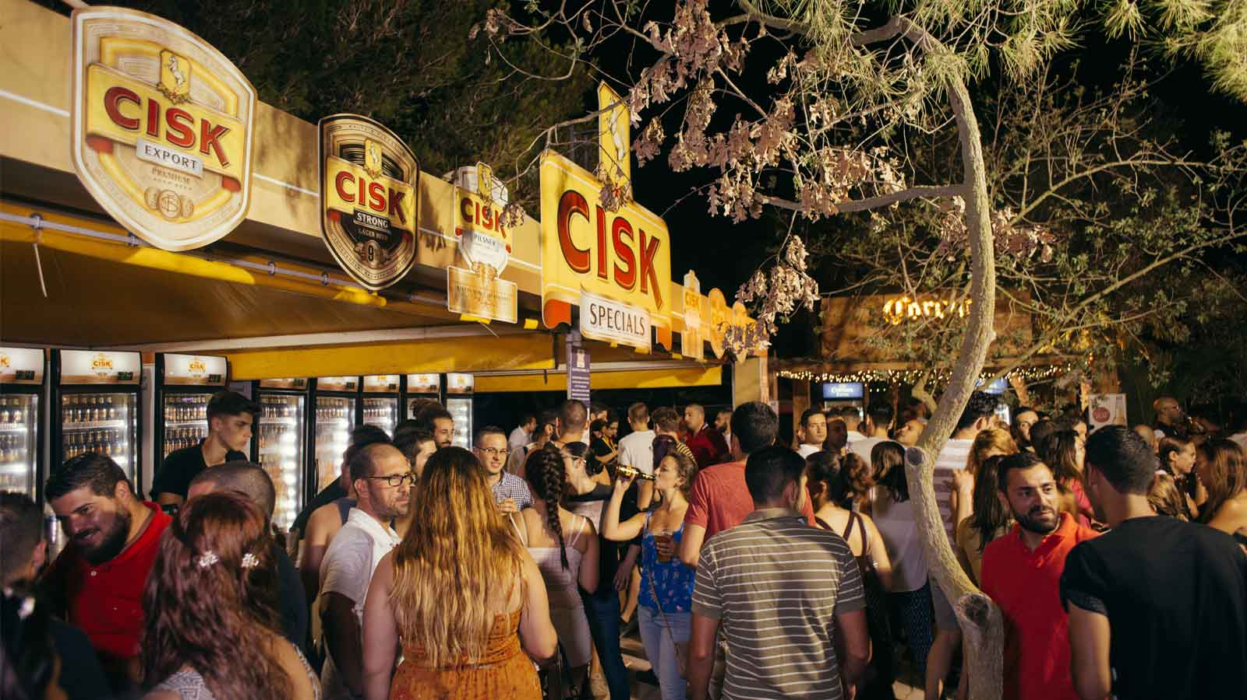
Price: Free entrance
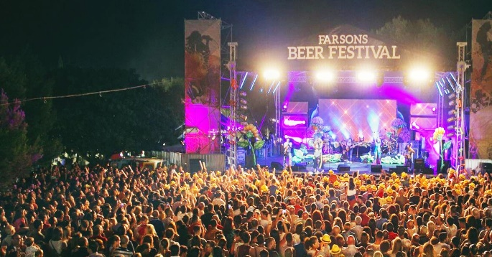
As one of Malta’s most awaited summer events, drawing thousands of festival goers every night, the festival will once again feature a selection of local and international award-winning beers, no less than 70 local artists and performances, and a food court offering a diverse choice of foods.
The choice of local and international award-winning beers on offer is the main highlight of the festival with the wide range.

August 2024

Summer Daze Festival
Dates: TBA
Website: https://summerdazemalta.com/
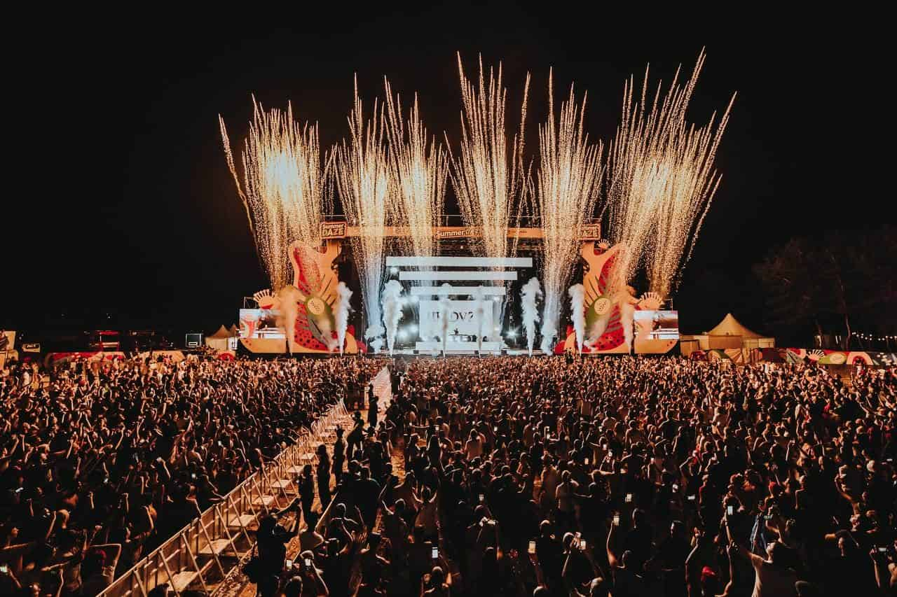
Price: TBA
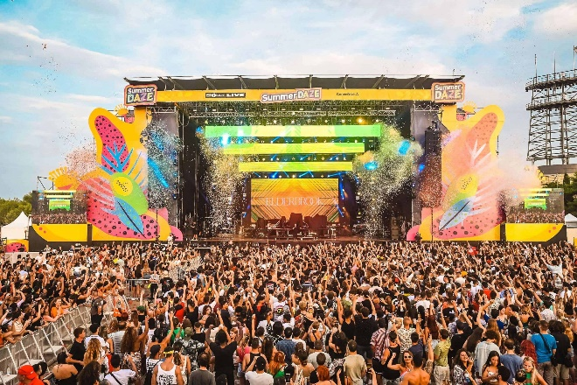
Summer Daze Malta is a music and dance festival. The festival hosts world-famous artists every year. So far, many different artists have performed from David Guetta to Rita Ora, Tyga to Paul Kalkbrenner. Summer Daze Malta, held in São Paulo Bay and Ta'Qali National Park, attracts many locals and foreigners who love music.

September 2024

Malta Pride
Dates: TBA
Website: https://europride2023.mt/
Price: Free Entrance

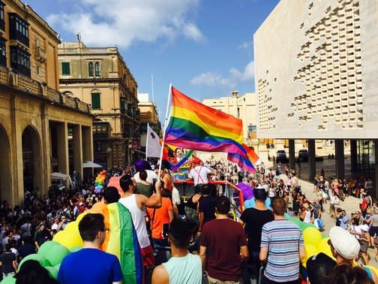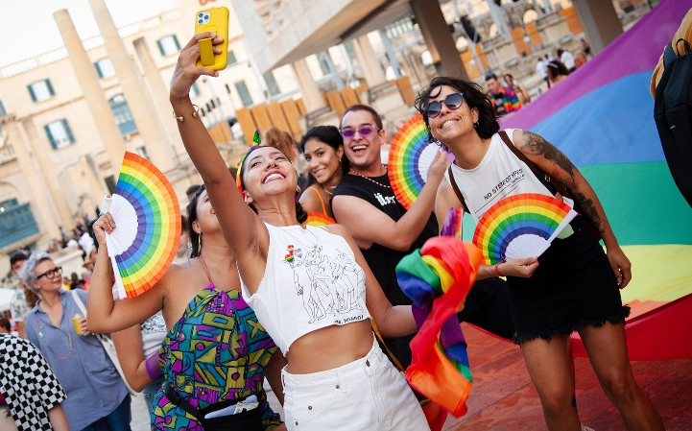

The Maltese LGBTIQ+ Community is a proud part of a European LGBTIQ+ Movement, but also finds itself at the heart of the Middle East and North African regions where equality is still a far cry. With Malta ranking top of the ILGA Rainbow Index for five years in a row, it is our duty to work constantly in achieving full equality from the heart in Malta as well as in neighbouring communities where LGBTIQ+ phobia and lack of human rights are still rife.

October 2024

Birgu Festival
Dates: TBA
Website: https://www.birgucandles.mt/blogs/relax-with-wax/birgu-fest-2023
Price: Free Entrance

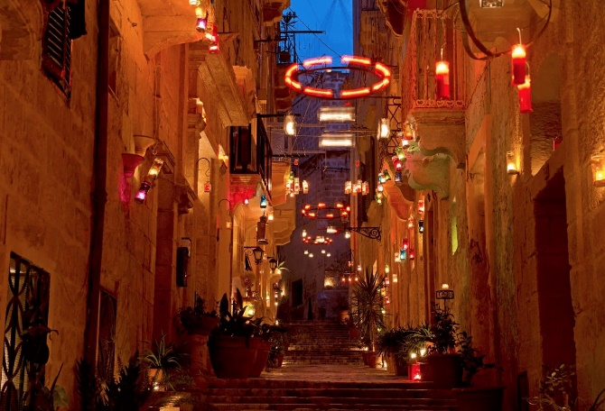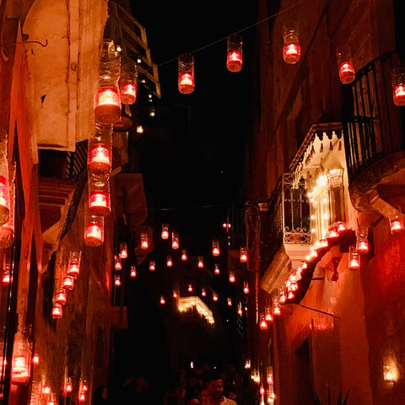

The festival of light that illuminates Birgu's winding medieval streets with the gentle glow of thousands of candles will have a few changes for this year with excavations currently taking place in the main square, with most of the entertainment taking place elsewhere around Birgu. The local council and the people of Birgu open their streets and their doors to all, to create a magical and memorable experience!

